
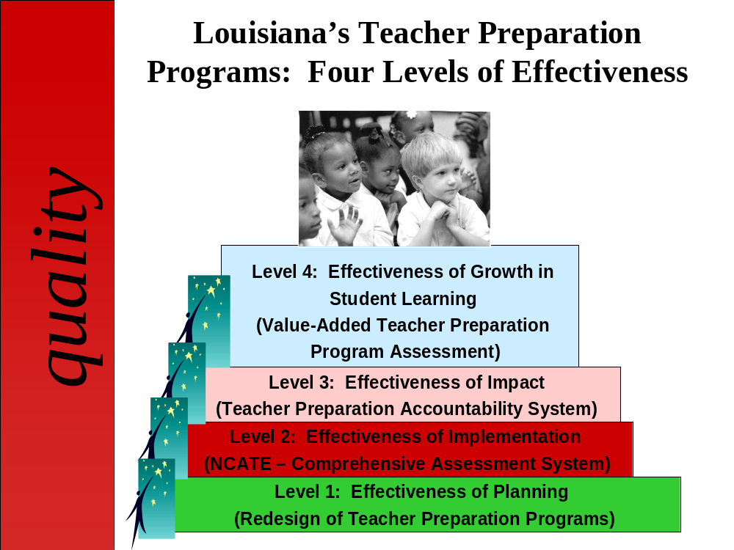
http://regents.louisiana.gov/index.cfm?md=pagebuilder&tmp=home&pid=113

LOUISIANA’S TEACHER PREPARATION PROGRAMS:
FOUR LEVELS OF EFFECTIVENESS

LEVELS | OUTCOMES
LEVEL 4: Effectiveness of Growth in Student Learning  (Value Added Teacher Preparation Program Assessment)   | A Value Added Teacher Preparation Program Assessment Model was developed during 2003-2004. The model examines the effectiveness of teacher preparation programs in preparing new teachers whose students demonstrate academic growth. The model was piloted during 2003-2004 and 2004-2005 using achievement data of students in grades 4-9 within 10 school districts. The model was then piloted during 2005-2006 and 2006-07 using achievement data of students in grades 4-9 in all school districts and data for all public and private teacher preparation programs in Louisiana. Initial results for the teacher preparation programs and names of the teacher preparation programs were released to the public during October 2007, December 2008, and August 2009.
LEVEL 3: Effectiveness of Impact  (Teacher Preparation Accountability System)   | All public and private teacher preparation programs in Louisiana are assigned Teacher Preparation Performance Scores and labels on an annual basis as part of the Teacher Preparation Accountability System. The Teacher Preparation Performance Score is calculated based upon indicators for an Institutional Performance Index and Quantity Index. Universities with labels of Exemplary and High Performing are provided monetary rewards. Universities assigned labels of At-Risk or Low Performing move into Corrective Action. (Note: Due to Hurricane Katrina and Hurricane Rita impacting schools and universities in Louisiana, new baselines are now needed for the Quantity Index. The state’s Blue Ribbon Commission for Educational Excellence is now revising the system.)
LEVEL 2: Effectiveness of Implementation  (NCATE) | 100% of the established public universities in Louisiana have successfully addressed national standards for teacher preparation and are accredited by the National Council for Accreditation of Teacher Education (NCATE). All established private universities in Louisiana have attained NCATE accreditation. Two new public and private universities are now pursuing national accreditation. All teacher preparation programs have developed comprehensive assessment systems.
LEVEL 1: Effectiveness of Planning (Redesign of Teacher Preparation Programs) | All public and private universities in Louisiana with teacher preparation programs redesigned their PK-3, 1-5, 4-8, 6-12, and K-12 programs and successfully developed comprehensive plans to recruit, prepare, and support new teachers. These programs were jointly developed by College of Education, College of Arts/Sciences, and district personnel. The programs were aligned with state K-12 content standards and state teacher standards and evaluated by national experts. All public and private universities are now implementing the new plans after receiving final approval from the Board of Regents and Board of Elementary and Secondary Education.

For additional information, please contact: Jeanne M. Burns, Ph.D. (jeanne.burns@la.gov). (10.07.10)

